Experiment 1

# Aim:

To develop and demonstrate a XHTML file that includes Javascript script

for the following problems:

a) Input: A number n obtained using prompt

Output: The first n Fibonacci numbers

b) Input: A number n obtained using prompt

Output: A table of numbers from 1 to n and their squares using alert

# Experiment 1a: Fibonacci Series

# XHTML:



Code : 1a.html

# Javascript:



Code : 1a.js

# Output:

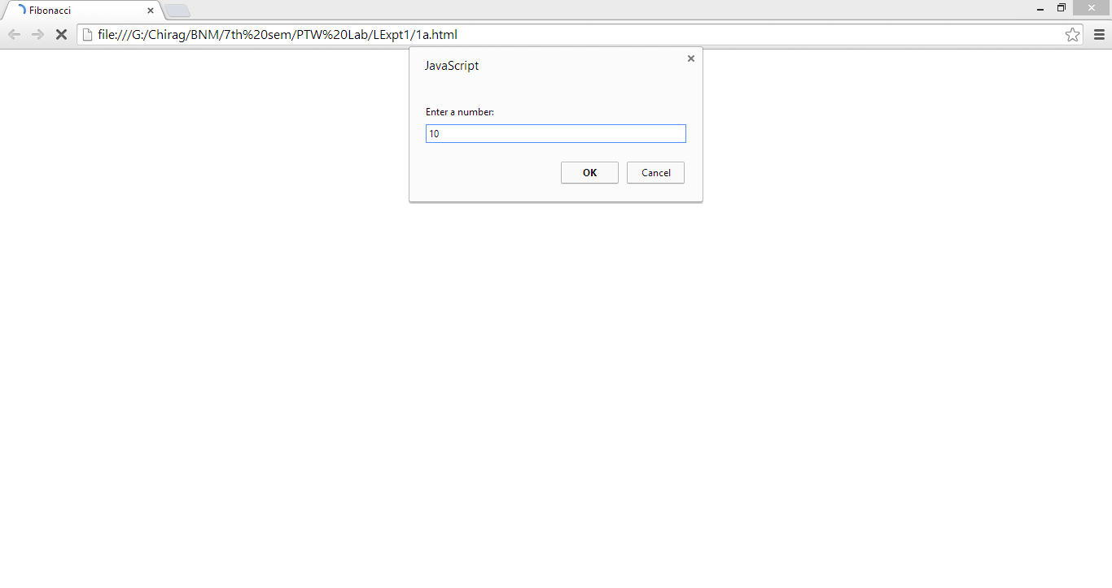

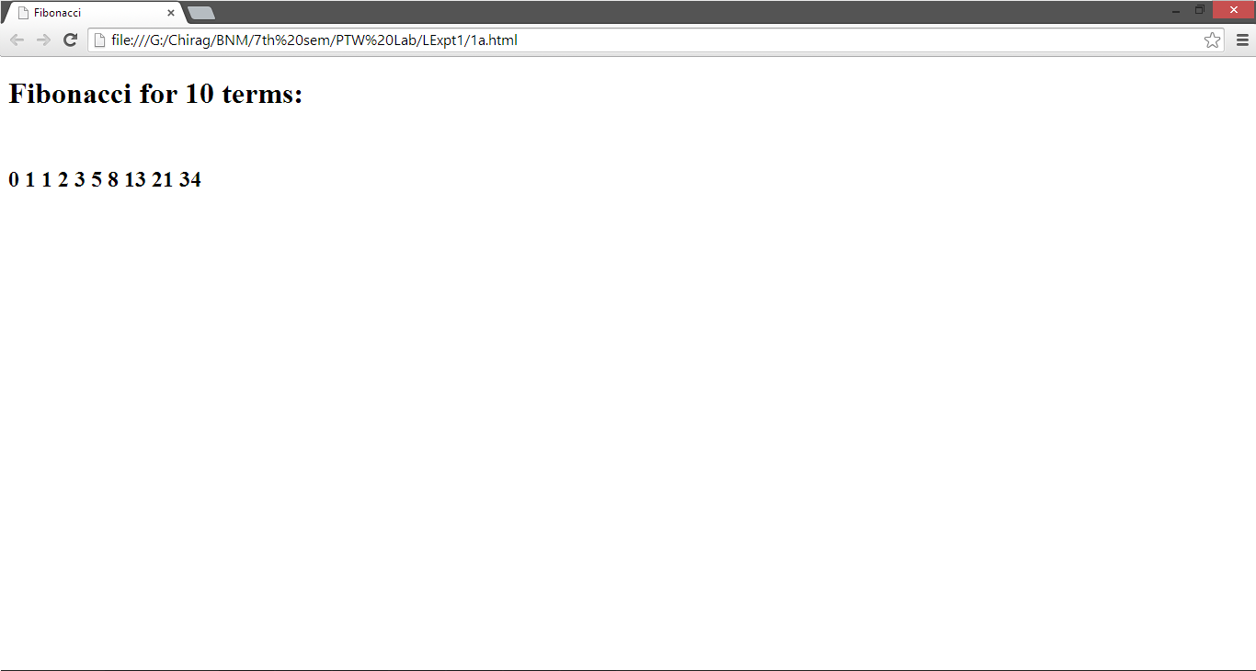

# Experiment 1b: Square Series

# XHTML:



Code : 1b.html

# Javascript:



Code : 1b.js

# Output:

